TEACHER:MWALE CH
DESIGN AND TECHNOLOGY DEPARTMENT
LESSON PLAN

SUBJECT: DESIGN AND TECHNOLOGY CLASS:…… … DATE:……/……./20…. DURATION:………….
BOYS:…………………… GIRLS ………………………………………. TOTAL OF PUPILS… TOPIC: TRIANGLES SUBTOPIC: TRIANGLES
LEARNING OUTCOMES LSBAT
- To construct a triangle to satisfy given conditions
RATIONALE
Knowledge: Construction of scalene triangles using sides
Skills; Accurate construction of triangles
Values: Awareness of methods of constructing triangle
TEACHING AIDS
……………………………………………………………………………………………………………………………………………

PART | LESSON CONTENT | METHODOLO GY | LEARNER ACTIVITY
introduction | - Recap on the previous lesson | Questions and answers | Provide answers
Developme nt | TRIANGLES  TO CONSTRUCT A TRIANGLE TO SATISFY GIVEN CONDITIONS  EXAMPLE ONE  Construct the scalene triangle given that AB= 85mm, AC= 95mm and BC= 70 mm.  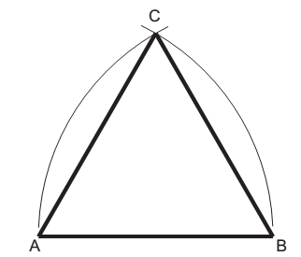  - Draw a base line AB= 85mm  - At centre A, radius AC=95mm construct an arc above as shown.  - At centre A, radius BC=70mm construct an arc to cross with the first arc at point C as shown.  - Join ABC using bold lines to give the required scalene triangle.  EXAMPLE TWO  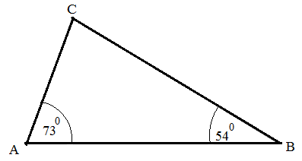  To construct a scalene triangle when two angles as 730 and 540 and the included side of 60mm  - Draw a line and mark off AB= 60 on it.  - At point construct angle 730 at A and 54 at B  - The two lines meet at C.
Application | CLASS EXERCISE  - Construct the following scalene triangle  - Given that AB= 89mm, AC= 80 mm and BC= 75 mm  - Given that AB= 90mm, AC=110, CAB= 420  - Given that AB=BC=AC=68  - Right angle triangle given that AB= 60, BC=80, AC=100 | Questions And Answers | Provide answers
Conclusion | - Recap on the main steps and points | V/E
LESSON EVALUATION

TEACHER:MWALE CH
DESIGN AND TECHNOLOGY DEPARTMENT
LESSON PLAN

SUBJECT: DESIGN AND TECHNOLOGY CLASS:…… … DATE:……/……./20…. DURATION:………….
BOYS:…………………… GIRLS ………………………………………. TOTAL OF PUPILS… TOPIC: TRIANGLES SUBTOPIC: TRIANGLES
LEARNING OUTCOMES LSBAT
- Construct an isosceles triangle given the perimeter and the altitude
RATIONALE
Knowledge: Construction of scalene triangles using sides
Skills; Accurate construction of triangles
Values: Awareness of methods of constructing triangle
TEACHING AIDS
PART | LESSON CONTENT | METHODO LOGY | LEARNER ACTIVITY
Introduct ion | - Recap on the previous lesson | Questions and answers | Provide answers
Develop ment | TRIANGLES  EXAMPLE ONE  Construct an isosceles triangle given the perimeter 180mm and the altitude 60mm  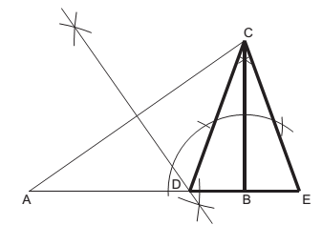  - Draw line AB equal to half the perimeter.  - From B erect a perpendicular and make BC equal to the altitude.  - Join AC and bisect it to cut AB in D.  - Produce DB so that BE= BD. CDE is the required triangle  EXAMPLE TWO  To construct a triangle given the perimeter 120mm and the ratio 4:3:6  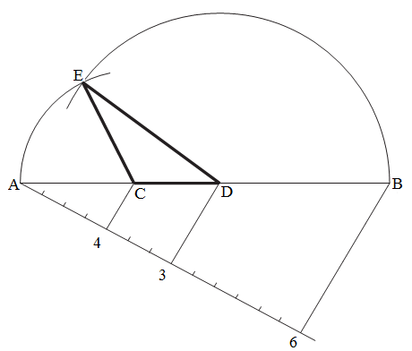  Draw the line AB equal in length to the perimeter.  - Divide AB into the required ratio 4:3:6.  - With centre C and radius CA, draw an arc.  - With centre D and radius DB, draw an arc to intersect the first arc in E.  - ECD is the required triangle
Applicati on | CLASS EXERCISE  - Construct an isosceles triangle given the perimeter 180mm and the altitude 60mm  - To construct a triangle given the perimeter 120mm and the ratio 4:3:5 | Questions And Answers | Provide answers
Conclusi on | - Recap on the main steps and points | V/E
LESSON EVALUATION

HOME WORK/ EXERCISE

TOPIC: TRIANGLES CLASS:………………………….. DATE:…………………………..

- Construct an equilateral triangle with sides 60 mm long.
- Construct an isosceles triangle that has a perimeter of 135 mm and an altitude of 55 mm.
- Construct a triangle with base angles 60 ° and 45 ° and an altitude of 76 mm.
- Construct a triangle with a base of 55 mm, an altitude of 62 mm and a vertical angle of 37.50
- Construct a triangle with a perimeter measuring 160 mm and sides in the ratio 3:5:6.
- Construct a triangle with a perimeter of 170 mm and sides in the ratio 7:3:5.
- Construct a triangle given that the perimeter is 115 mm, the altitude is 40 mm and the vertical angle is 45 °
- Construct a triangle with a base measuring 62 mm, an altitude of 50 mm and a vertical angle of 60 ° . Now draw a similar triangle with a perimeter of 250 mm.
- Construct a triangle with a perimeter of 125 mm, whose sides are in the ratio 2:4:5.

